**Experiment no. 13**

**Name: Sonali Dattatray Kaingade**

**PRN: 21620002**

**Title:**  WAP for Baye's classification

**code:**

#include <bits/stdc++.h>

using namespace std;

map<string,int>class_attri_cnt;

vector<string>attributes;

map<string,map<string,map<string,int>>>attribute_yn_cnt;

double calculateProbability(string Outlook,string Temp,string Humidity,string Wind,string playgame){

for(auto it: attributes){

// cout << it << " ";

}

double yes_cnt = class_attri_cnt["Yes"];

double no_cnt = class_attri_cnt["No"];

double total = yes_cnt + no_cnt;

double ans = class_attri_cnt[playgame]/total * (attribute_yn_cnt[attributes[0]][Outlook][playgame])/(class_attri_cnt[playgame]) *(attribute_yn_cnt[attributes[1]][Temp][playgame])/(class_attri_cnt[playgame])*(attribute_yn_cnt[attributes[2]][Humidity][playgame])/(class_attri_cnt[playgame])* (attribute_yn_cnt[attributes[3]][Wind][playgame])/(class_attri_cnt[playgame]);

return ans;

};

int main(){

ifstream input("info-gain.csv");

string line, day, outlook, temp, humidity, wind, playGame;

int j = 0;

while(getline(input,line)){

stringstream str(line);

getline(str,day,',');

getline(str,outlook,',');

getline(str,temp,',');

getline(str,humidity,',');

getline(str,wind,',');

getline(str,playGame,'.');

if(j==0){

j++;

attributes.push_back(outlook);

attributes.push_back(temp);

attributes.push_back(humidity);

attributes.push_back(wind);

continue;

}

class_attri_cnt[playGame]++;

attribute_yn_cnt[attributes[0]][outlook][playGame]++;

attribute_yn_cnt[attributes[1]][temp][playGame]++;

attribute_yn_cnt[attributes[2]][humidity][playGame]++;

attribute_yn_cnt[attributes[3]][wind][playGame]++;

}

double yes_cnt = class_attri_cnt["Yes"];

double no_cnt = class_attri_cnt["No"];

double total = yes_cnt + no_cnt;

cout << "Enter the unknown case" << endl;

string Outlook, Temp, Humidity, Wind;

cin >> Outlook >> Temp >> Humidity >> Wind;

double p_yes = calculateProbability(Outlook, Temp, Humidity, Wind,"Yes");

double p_no = calculateProbability(Outlook, Temp, Humidity, Wind,"No");

//cout << p_yes << p_no << endl;

if(p_yes > p_no ) {

cout << "The unknown case is classified as Yes" ;

}

else cout<< "The unknown case is classified as No";

}

**Result:**

**Input.csv:**

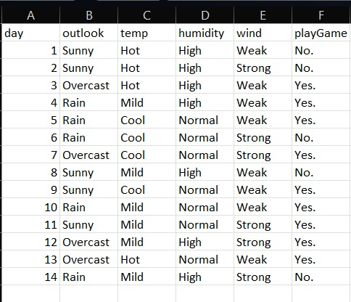

**Output.csv:**

